Suistnable Development

# Team Name- It Broken

## Theam- Suistnable Development

## Edition - Embedded

# Project-: Multipurpose Robot

Hey everyone as the name indicate that the robot has been designed by our team is basically for doing multiple task at a time in different fields.

The different field are as follows-:

1. Agriculture.

2. Mining.

3. Military.

As I am working on the suistnable development goal. So I would like to start from the Agriculture.

* Agriculture-:

Agriculture is the process of producing food, feed,fiber and many other desired products by the cultivation of certain plants and the raising of domesticated animals.

The practice of agriculture is also known as "farming", while scientists, inventors and others devoted to improving farming methods and implements are also said to be engaged in agriculture

* Problem Faced by the farmers-:

1. Soil Moisture.

2. Fear of destroying the crops by animal.

3. Improper Irrigation.

4. Required Maintenance.

* Military-:

Military robots are autonomous robots or remote-controlled mobile robots designed for military applications, from transport to search &rescue.

Autonomous robotics would save and preserve soldiers' lives by removing serving soldiers, who might otherwise be killed.

Machines don't get tired.

Normal temperature of border like Jaisalmer Border may be approx 40 C and Humidity may 95% but after bomb explosion the rise in temperature and humidity may rise with the intensity of bomb.

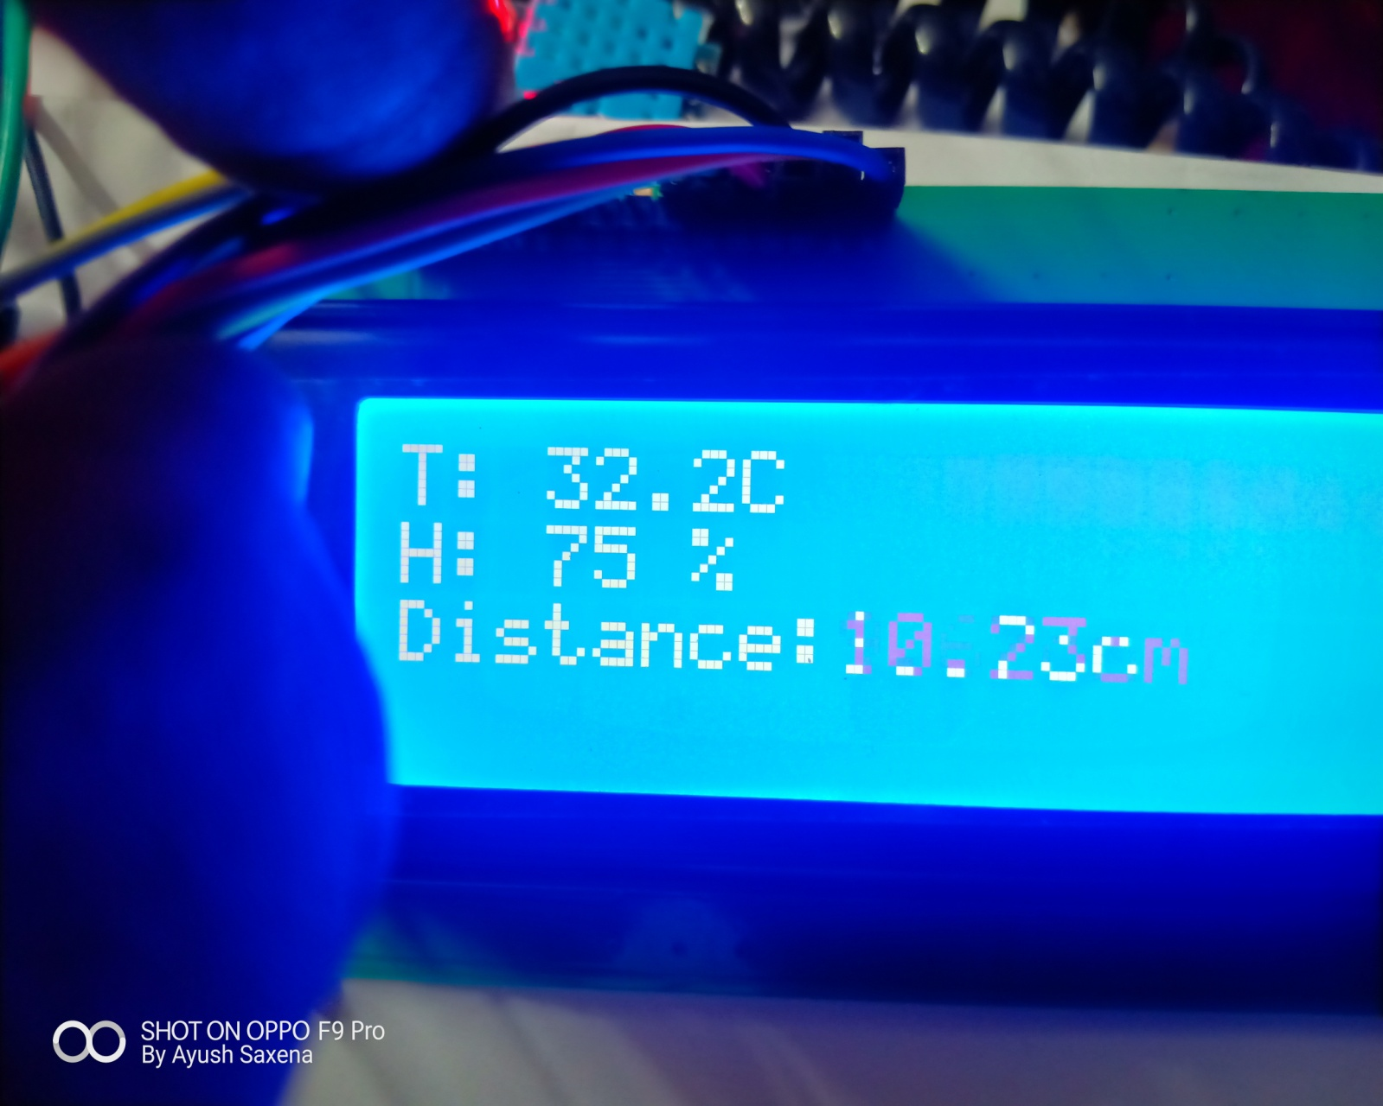

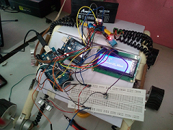

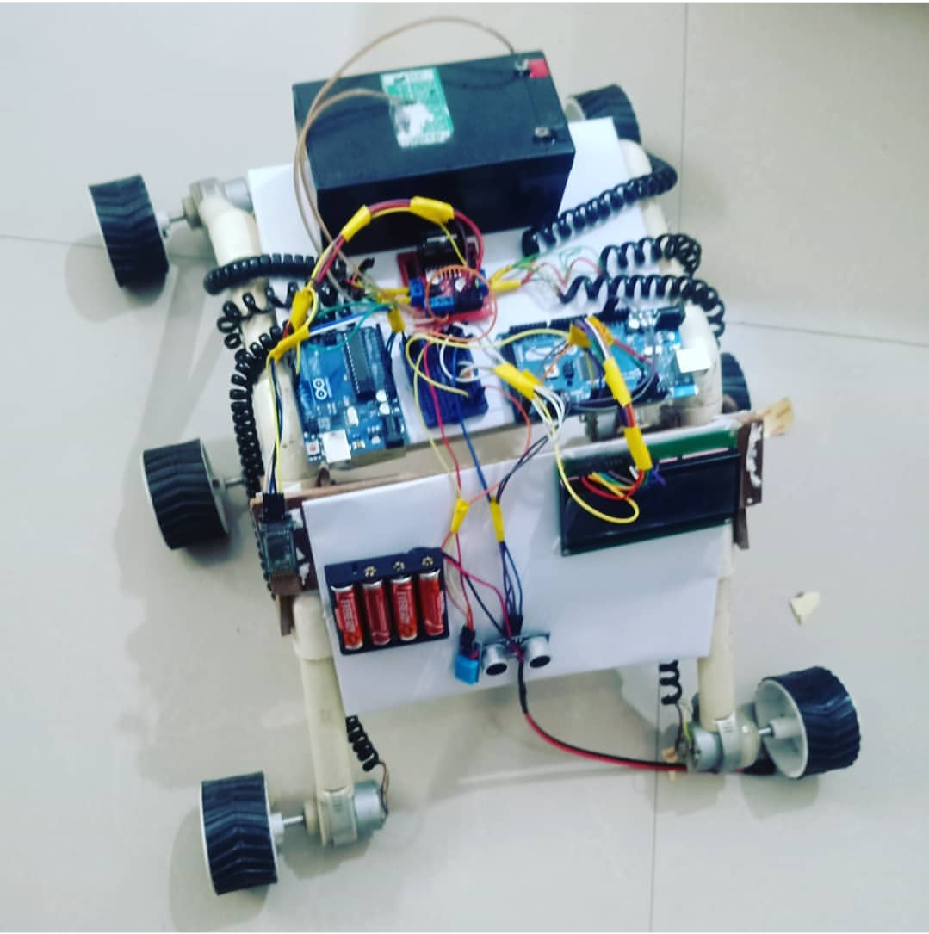

Team Members-:

Ayush Saxena

Garima Singh

Prashant Kumar